* **Title Page: cs 1011-051 – Lab 7 <BattleSimulator3000>**
* <Denise Malisa>
* <10/26/2020>
* <Page Break>
* **I. Objectives**

The objective of this lab is to create a battle game where a user is the valiant warrior and the user is playing against Mugwump whose steps and choices of play are generated by the program. The each take swings at each other by getting chances through rolling die. The program determines the number of attacks and damage received for each player. The player with the highest amount of hit points has won. The main objective is for me to be able to use user defined classes.

* **II. Requirements**

I had to create the classes and manipulate them to execute the program. I created a class to test my progress as I build up the program. The program is supposed to ask the user if they want to play again and give them the respective ways of indicating that, and if they don’t put any of those ways it will stop the program. Then the program is supposed to roll different types of die a number of different times to give us certain outputs like the hitpoints etc.

* **III. Design:**

The UML class diagram for the Die class, as well as the other classes required for your assignment, are shown below.

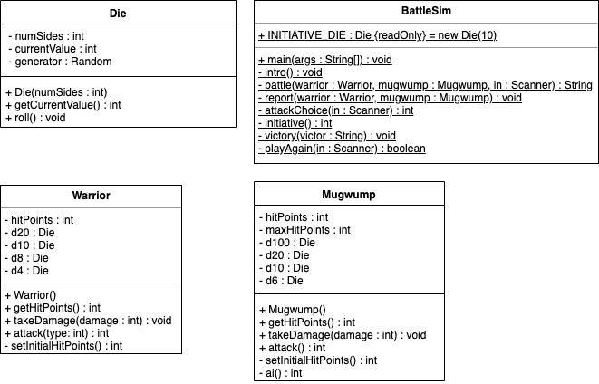

* **III. Test Plan/Test Strategy**
* Test1:

Firstly, I want to test that I am getting values for warrior and mugwump’s initial values.

I will check this in my warrior driver class which I used to just test things.

Test2:

Then in BattleSim I want to check my play again loop which will be asking the user if they want to play again.

In the case that they want to play again they can type Y,y,yes or Yes, and if they don’t they can type n,N,no or No and it is supposed to end if they don’t enter any of the options.

Test3:

The last test will be to test that the program runs and outputs values correctly.

* **IV. Results**

Test1:

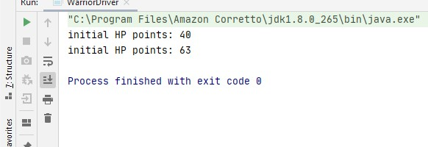

Test 2:

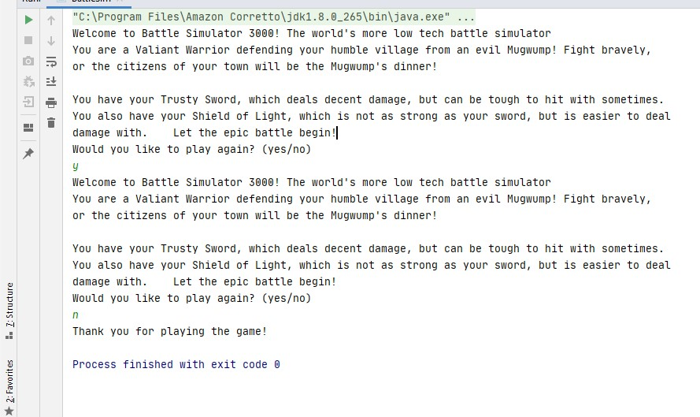

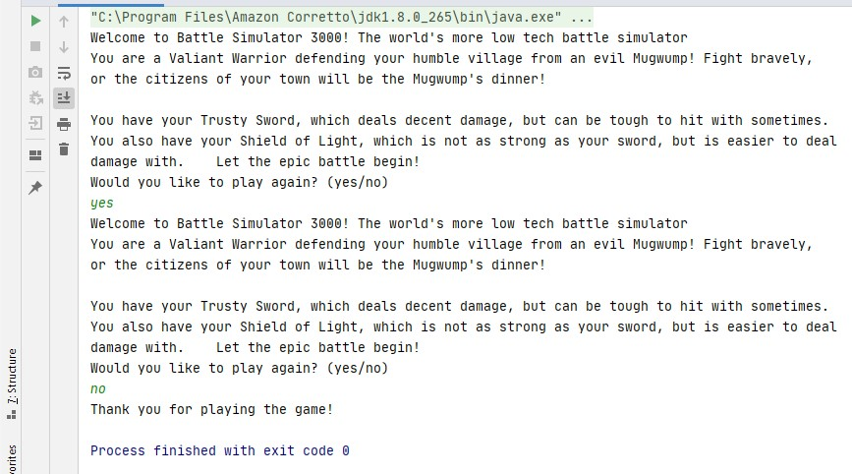

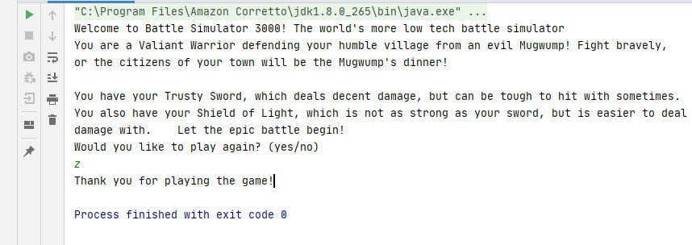

Test3:

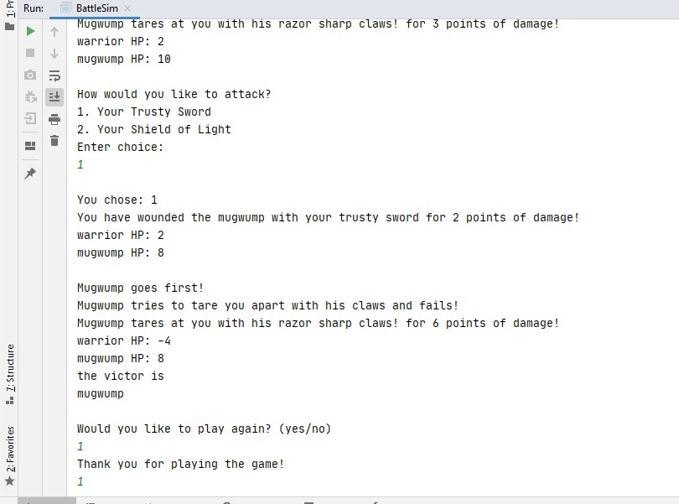

The code works perfectly, the correct values are being output and mugwump hitpoints and healing works properly. However, mugwump actions are being printed twice but only the second one counts or rather, works correctly. The first is just a redundant statement.

* **V. Discussion**

I have learnt how to create stubs so that I can be able to test my program as I go. I have also learnt how to create user defined classes, how to create instances of a class

There was an issue where I wasn’t getting an initial HP value for either mugwump or warrior, only to realize that my error was that their constructors were set to return void. It was a very small error but I took a lot of time trying to find it.

I struggled to fix the redundant first mugwump action statement. And I still didn’t manage to fix that one.